Docker Assignment-2

**Question**: From the git repo having two branches 2024Q1 and 2024Q2 with file index.html deploy that on two slaves of Jenkins using SSH connection on port 80 for both slaves

* Launce a ec2 instance
* Install java 11
* Install Tomcat
* Download Jenkins war file in webapps folder of Tomcat and start the Tomcat.
* Create a Github repo with 2 branches as shown is SS below and insert a index.html file in it.
* 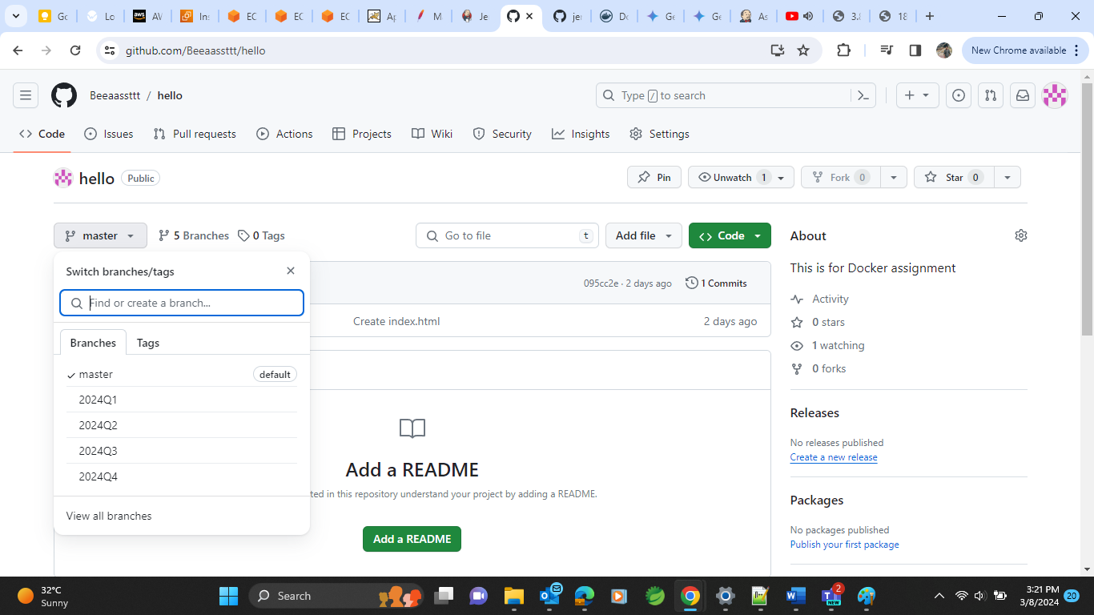
* Do connection of slaves with Master with SSH connection
* Create and home root path for slaves named as “slave-1” and “slave-2” for both slaves of slave1 and slave2 accordingly.
* Do SSH connection with configs like
* 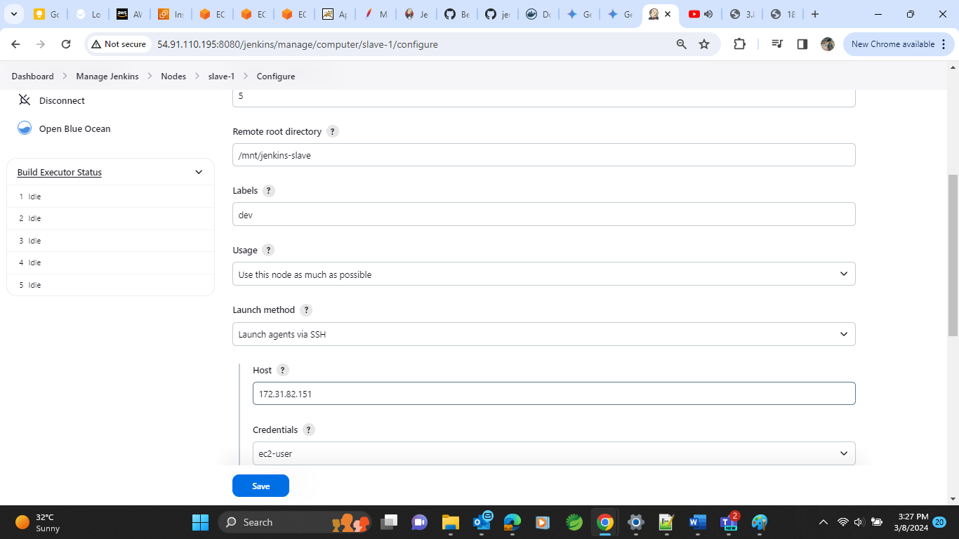

* Follow the above process for both slaves according to their configs
* Both slave will now be having connection with Master now as shown below

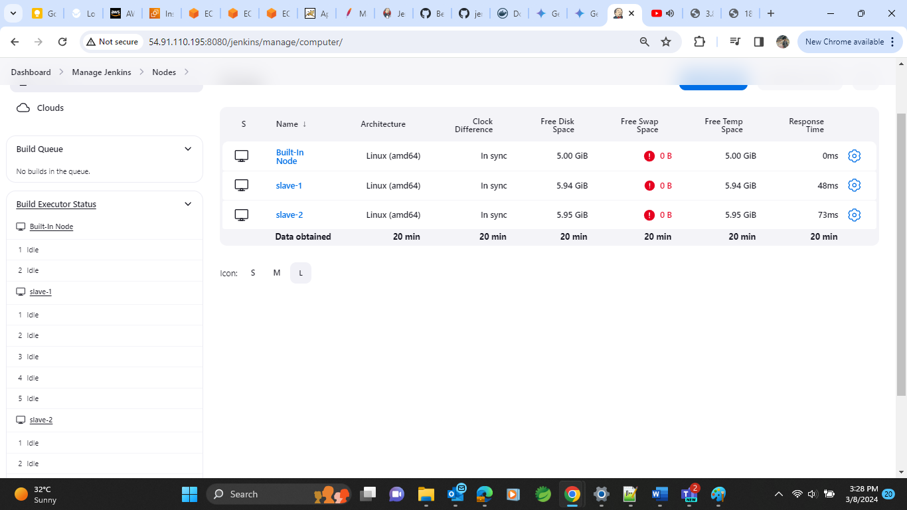

* After all the configurations as per shown in previous docs of Jenkins assignment we will be able to see Jenkins UI like this.

* Create a job here named as ASS2 with pipeline option selected and do some configurations shown in ss below

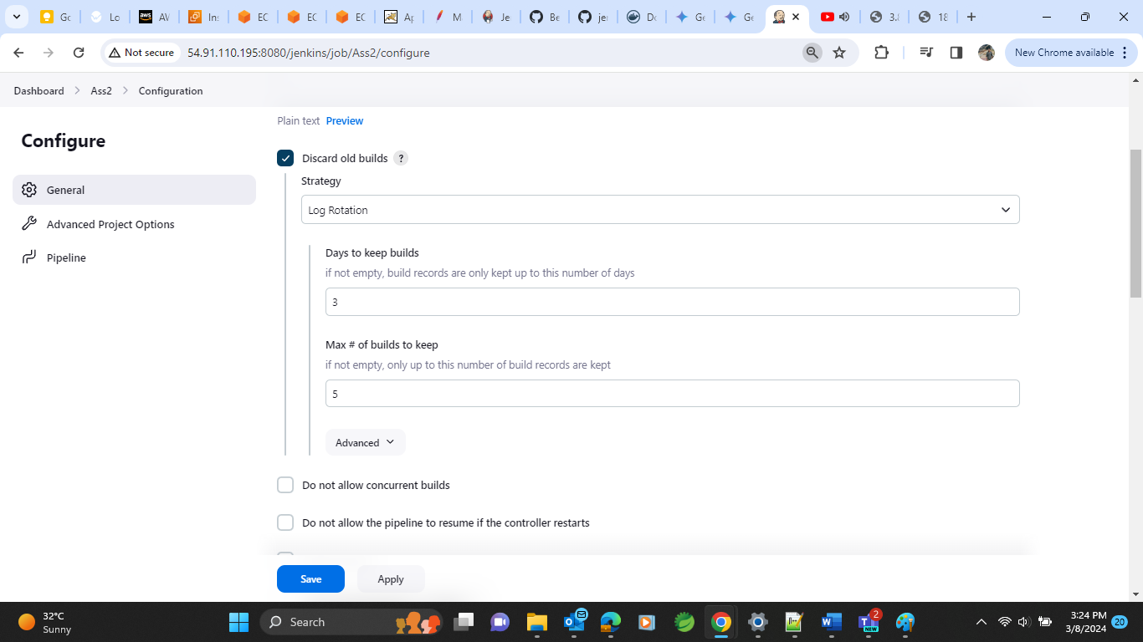

Save and apply to run the build.

* We will achieve our required output showing like 2024Q1 branch index file on slave 1 and 2024Q2 branch index file on slave-2 on port 80 for both
* **This is for slave 1**

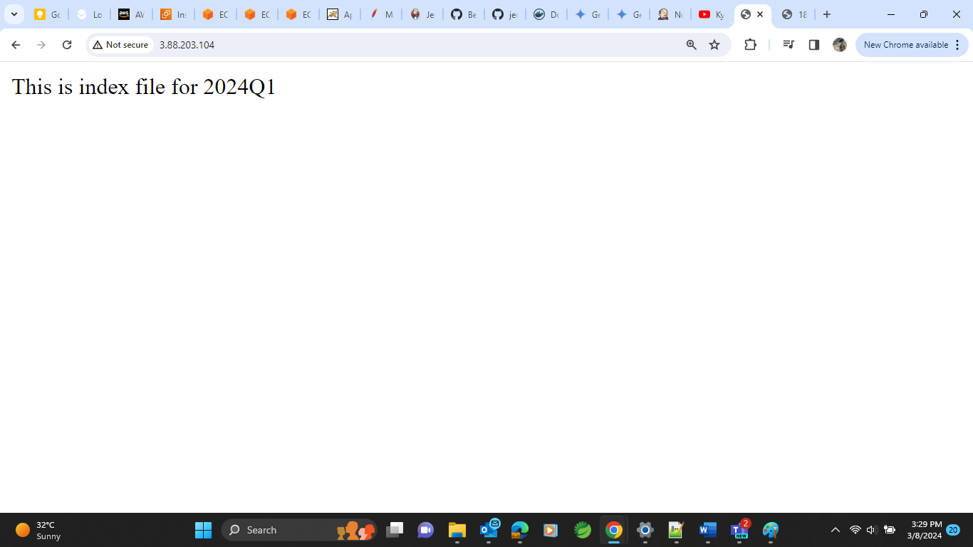

* **This is for slave 2**

